Lab Alumni

Christina Bruce
Former Undergraduate Student, Lab Assistant

Wellesley College

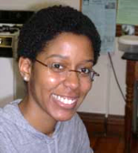

Young Joon Choi
Former Graduate Student

Research Fellow
yjchoi(at)korea.ac.kr
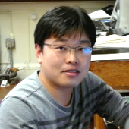

Andrew Draginis
Former Undergraduate Student -- Lab Assistant

dragin(at)fas.harvard.edu
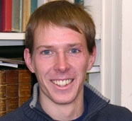

Zaiwei Ge
Former Postdoctoral Fellow

Zaiweige(at)gmail.com

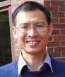

Sam Hammer
Former Graduate Student

Professor
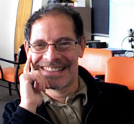
School of General Studies Boston University
cladonia(at)bu.edu

Karen Hansen
Former Postdoctoral Fellow

Sr. Curator
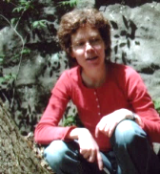
Kryptogambotanik Naturhistoriska riksmuseet Stockhom
karen.hansen(at)nrm.se

David Hewitt
Former Graduate Student

Philadelphia Academy of Natural Sciences
davidhewitt(at)post.harvard.edu
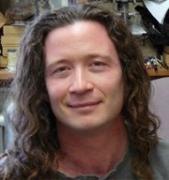

Shah Hussain
Former Graduate Student Intern

Hazara University, Mansehra, Pakistan

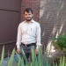
Sana Jabeen
Former Graduate Student Intern

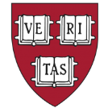
University of Punjab, Lahore, Pakistan

Andrew Janjigian
Former Extension School Student

Francisco Kuhar
Former Visiting Postdoctoral Fellow

Centro de Investigación y Extensión Forestal Andino Patagónico (CIEFAP), Argentina

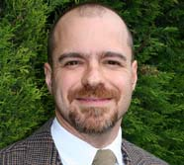
Scott LaGreca
Former Curatorial Associate

Curator
Plant Pathology Herbarium, Cornell , Ithaca, NY
sal66(at)cornell.edu

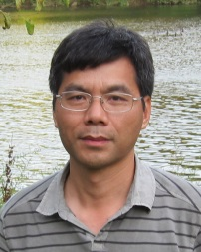
Bin Liu
Former Graduate Student

Professor
Agric. College Guangxi Univ., Nanning China
liubin(at)gxu.edu.cn

Ingrid McDonough
Former Faculty Assistant

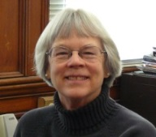

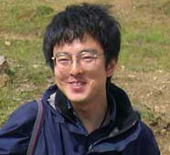
Hidetsugu Miwa
Former Visiting Researcher

Institute of Statistical Mathematics , Tokyo, Japan
glider(at)eb.mbn.or.jp

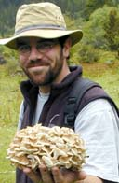
Brian Perry
Former Graduate Student

Biology Dept., University of Hawaii
brian_perry(at)post.harvard.edu

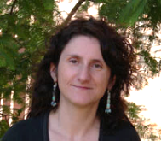
Kris Peterson
Former Graduate Student

krpeterson(at)post.harvard.edu

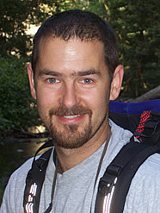
Matthew E. Smith
Former Postdoctoral Fellow

1-352-273-2837
trufflesmith(at)ufl.edu

Malka Saba
Former Graduate Student Intern

University of Punjab, Lahore, Pakistan

Feng Xu
Former Visiting Postdoctoral Fellow

Beijing Academy of Agriculture and Forestry Sciences, China
xxu1022(at)163.com

Chang Lin Zhao
Former Visiting Postdoctoral Fellow

Beijing Forestry University, China

